PRACTICAL 1 – SCREENSHOT REPORT
SDLC AND STLC PHASES
Sample Project: Online Shopping Website
Date: ____________________

Aim
To understand the phases of the Software Development Life Cycle (SDLC) and Software Testing Life Cycle (STLC) for a real-world software project and identify the testing activities performed during each development stage.

Problem Statement
Consider an online shopping website where users can register, browse products, add items to a cart, make payments and track orders. Describe the major SDLC phases and explain the testing activities that support each phase.

Tools / Documents Used
Sr. No. | Tool / Document | Purpose
1 | SDLC / STLC phase model | Understand the development and testing workflow
2 | Requirement document | Record features and business rules
3 | Test plan and test cases | Plan testing and define expected results
4 | Bug report / defect log | Record issues found during testing
5 | Browser and test environment | Check the web application during testing

Project Overview
The sample project is an online shopping website. Main features include user registration and login, product search, cart management, checkout, payment and order confirmation. The same project is used throughout this practical to connect development activities with testing activities.

SDLC and STLC: Basic Difference
SDLC | STLC
SDLC describes the complete process of building and maintaining software. | STLC describes the structured activities performed to test software quality.
Includes requirements, planning, design, coding, testing, deployment and maintenance. | Includes requirement analysis, test planning, test design, environment setup, execution and test closure.

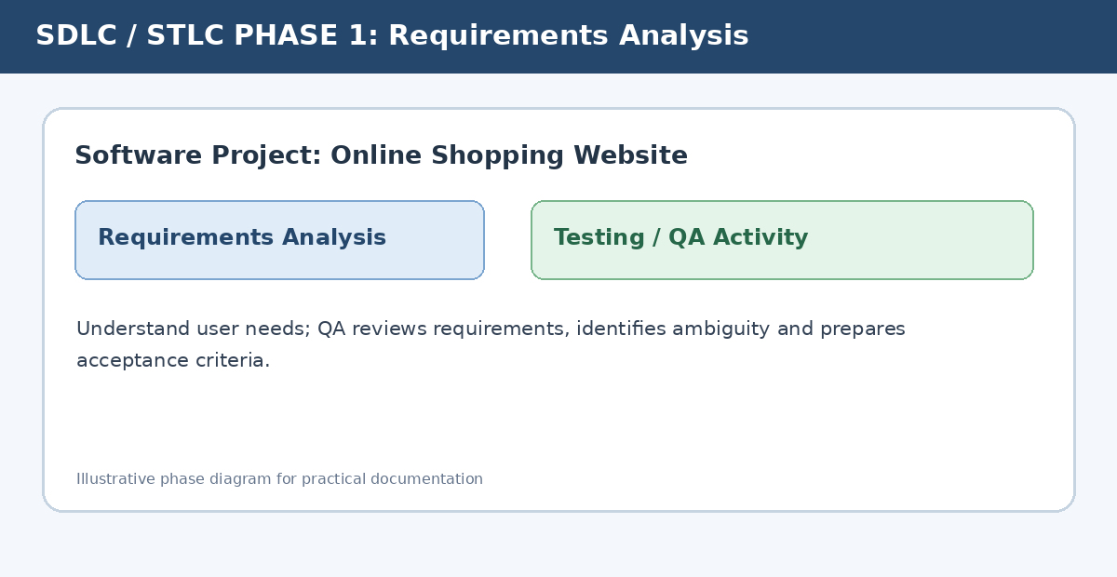

1. Requirement Analysis
In this phase, the team collects and studies the needs of customers and users. For the shopping website, requirements may include creating an account, logging in, searching products and placing an order.
Testing activities: QA reviews requirements, checks whether they are clear and testable, identifies missing cases, and prepares acceptance criteria. Example: confirm that the payment success message appears only after a successful payment.

2. Planning
The project team decides the schedule, resources, budget, responsibilities and risks. Testing effort and delivery dates are also planned.
Testing activities: prepare the test plan, define scope and objectives, select test types, estimate effort, identify test data and tools, and decide entry and exit criteria.
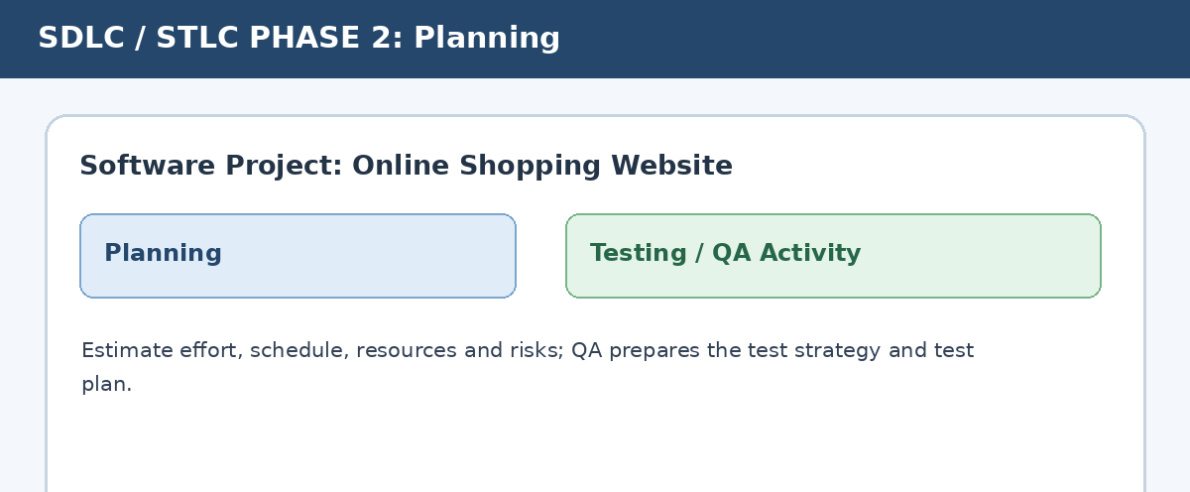

3. System Design
The team prepares the application architecture, database structure, page layouts and communication between modules. For example, the checkout page connects the cart, address, payment and order modules.
Testing activities: review the design, identify integration risks, prepare high-level test scenarios and plan test coverage for interfaces and data flow.
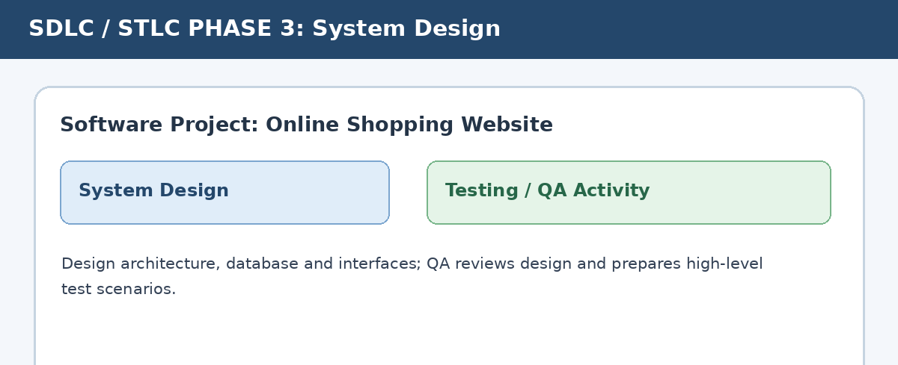

4. Development
Developers write code for the website features and connect the modules. Code reviews and version control help keep the implementation consistent.
Testing activities: prepare detailed test cases and test data, review requirements for test coverage, perform static reviews where applicable, and carry out unit testing with developers.
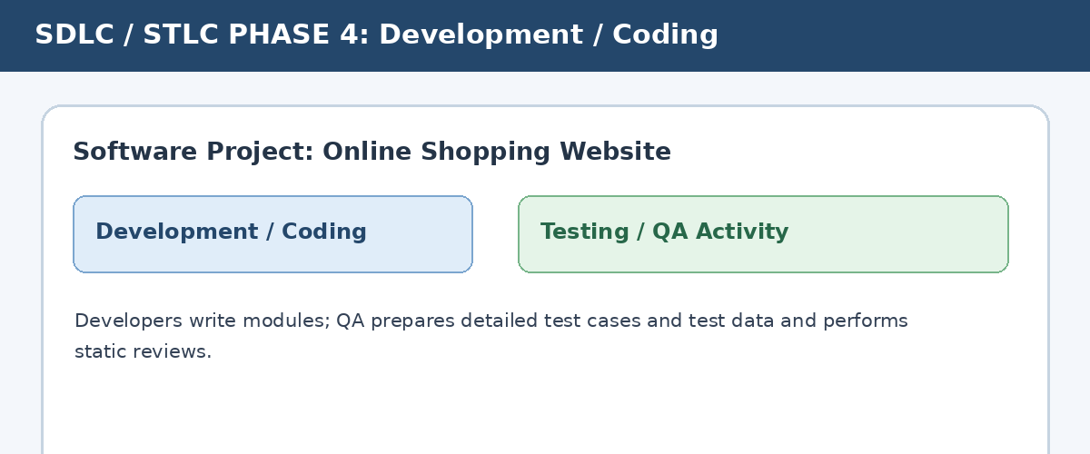

5. Testing
The completed modules are tested to check whether they meet the requirements. Testing may include functional, integration, system, usability, compatibility, security and acceptance testing.
Testing activities: execute test cases, compare actual and expected results, record defects with steps and evidence, retest fixed defects, perform regression testing and prepare a test summary.
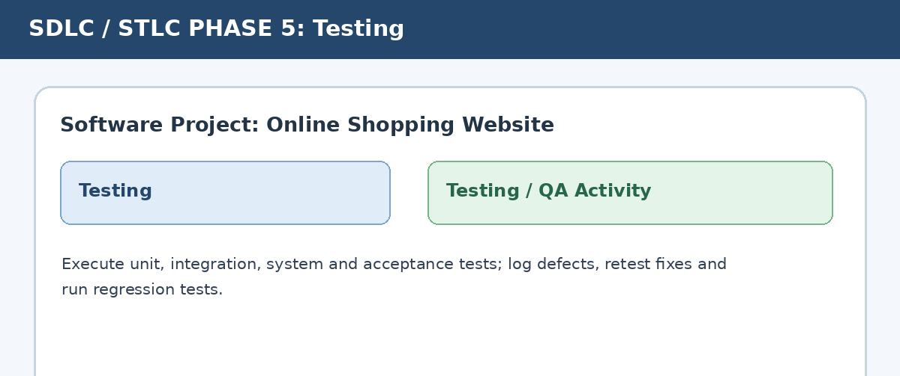

6. Deployment
After approval, the application is released to the production environment. Configuration and deployment steps are checked to ensure that the release is ready for users.
Testing activities: perform smoke or sanity testing on the deployed build, check key user journeys such as login and checkout, and confirm that critical features are available.
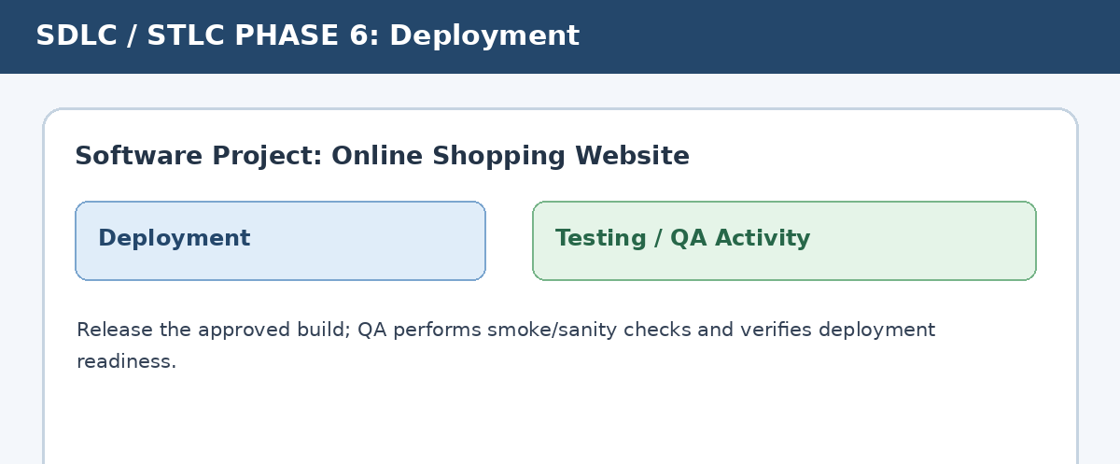

7. Maintenance
After release, the team monitors the website, fixes defects, improves features and updates the application when business needs change.
Testing activities: test bug fixes, run regression tests on affected areas, update test cases, and verify that changes do not break existing features.
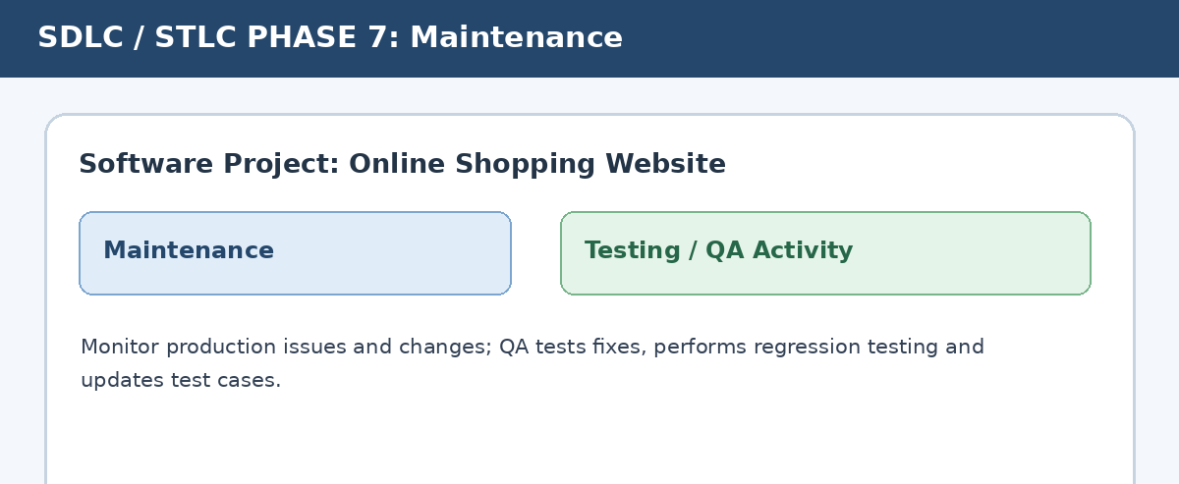

SDLC–STLC Activity Mapping
SDLC Phase | Testing Activities
Requirements Analysis | Requirement review, testability check, acceptance criteria
Planning | Test plan, scope, effort estimation, risks and resources
System Design | Design review, test scenarios, interface and integration risks
Development / Coding | Test case preparation, test data, static review, unit testing support
Testing | Execute tests, log defects, retest, regression and test summary
Deployment | Smoke / sanity checks and release verification
Maintenance | Fix verification, regression testing and test case updates

Observation
- Testing activities start during requirement analysis and continue through maintenance.
- Early requirement and design reviews can help find issues before coding is completed.
- Test cases and defect reports help the team track expected behaviour and resolve problems.
- Regression testing is important whenever a change or bug fix may affect existing features.

Conclusion
In this practical, the SDLC and STLC phases were studied using an online shopping website as a real-world example. The testing activities for each development stage were identified, from requirement review and test planning to test execution, release checks and maintenance testing. This shows that software testing is not limited to the final phase; it supports quality throughout the software life cycle.

Student Name: __________________________
Enrollment No.: _________________________
Class / Division: BCA Semester 3
Signature with Date: _____________________

